**Phase 1**

**Intro**

Google ad has a very important role in digital markreting

You see any company they largely use google ads for ther products

The result of Google ads are outstanding

If you see in Linked in there 6000 or 7000 thousand jobs in US monthly and fiver and upwark has demand for it that’s why teacher bought us google marketing complete course

IN this course you will learn how to make smart campaign , serch campaign, display campaign video campaigns , shopping campaigns and how to use google merchant

You will learn it all in the course

If you want to learn google ads in depth then this course is for you

You just have to do the course in depth and the strategies which are told to you implement it and you can also become a good digital marketer

And if you give only google advertisement services then there are many jobs and in freelance marketing jobs it has many demand

**Lesson 1:-**

In this lesson we will learn about **Introduction to Google Ads**

This is our Teachers profile s shown below

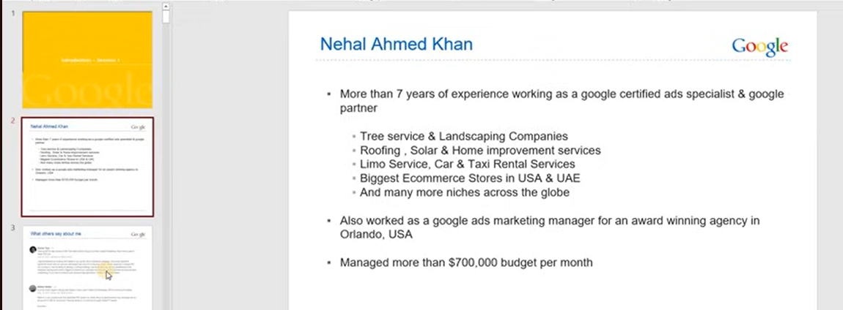

Now lets jump to introduction of Google Ads

Whatever we are studying it is important that what is basically a background or introduction

To undertand what is Google Ads which is shared by google itself as shoen below

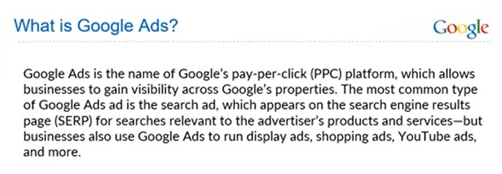

Basicallly Google Ads are also called Pay Per click platforms since it is based on Pay per click model

Whenever click on an ad than advertiser pay for it

It is not like someone sees the ad and he pays it

Through google ads not only search but also google propertieslike youtube , gmail , Discover differnet websites or app where people have apprived google ads sense

Googel ad sense connect advertisers to run ads

If in your website Google ADS sense is enabled then it measn that google ads advertisers can run ads on your website or apps

As the teacher says most common type of Google ASD is the Search type which appears on the Search engine result page relevant to advertiser product

Whover advertiser is running of any keyword for example we have a mobile phone product for example we are selling an iphone and we are running ad on iphone keyword like buy iphone in California means we are running a relevant key word which is relevant to our product that’s what it means in the definition

But Google ads is not just mainly pay per click platform you can ad different ads here for exmpale display ads, shopping ads , youtube ads and other ads like Performance max ads (who knows) , call only , dynamic search ad(who knows)

We will go to detail of each and every but for now you have to understand basic concept of google ads that What is Google Ads and what are they used for

Googel ad is basically a tool through which you can uise google other properties like youtibe,gmail, discover websites apps to run ads

Its main ourpose is search ads which appear on search result page relevnt to the advertiser , product or services

Now we will se example of search ads

What is this , How does it look and how does it work

We will see example to know how search ads make in google

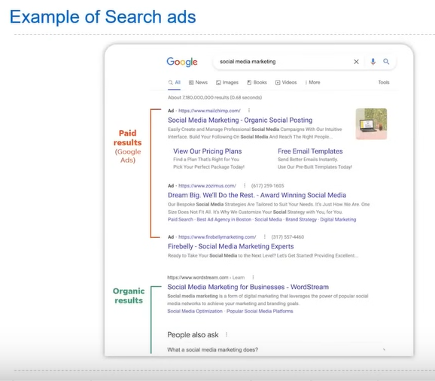

Now suppose we search social media marketing then above result will be shown

And the top 1,2,3 are ads and below it are not ads but organic result which has been achieved through SCO

This topic is not SCO nor Organic result we will just focus on ads which are sponsored

This is the topic for now

For practical we search something in google to see what type of search ads are there

Lets say we search social media marketing new York

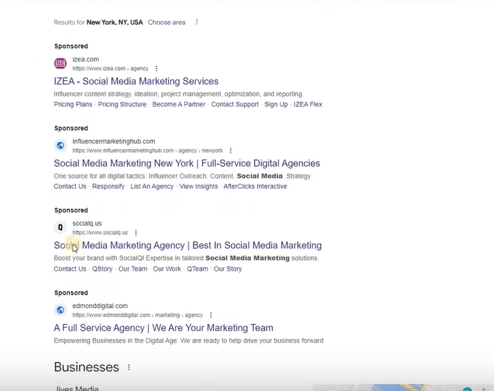

In top you will se sponsored ads but then we have organic results

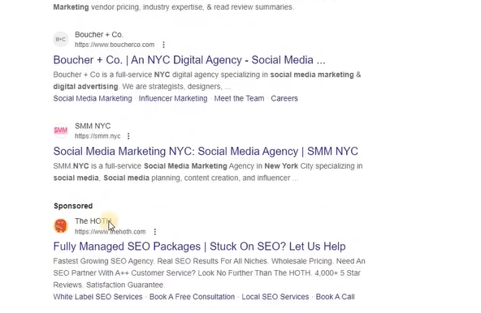

With the help of SCO and then we go below again and see sponsored result and this process keep going on

Whenever you sarch something against it you see the ad which is basically search based ad

Whenever you are searching something in Google and on the basis of that you se some ads is called search ads

It is also clled Text based whohc basically does not depend on graphics but on text

You can see the example below

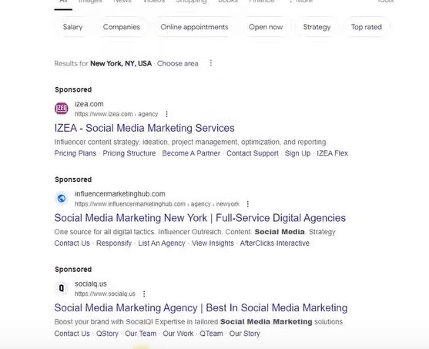

It is also called PPC ads because it revolves around it

How to run it , where to run it We will go into these details but ur topic is to understand these things but our topic for now is to understand these things that what it is and how does it look and we will break down it one by one and understand at micro level How does it work and set up for now our focus is now on understanding How does it look and what is the concept

Now below the example of Display ads

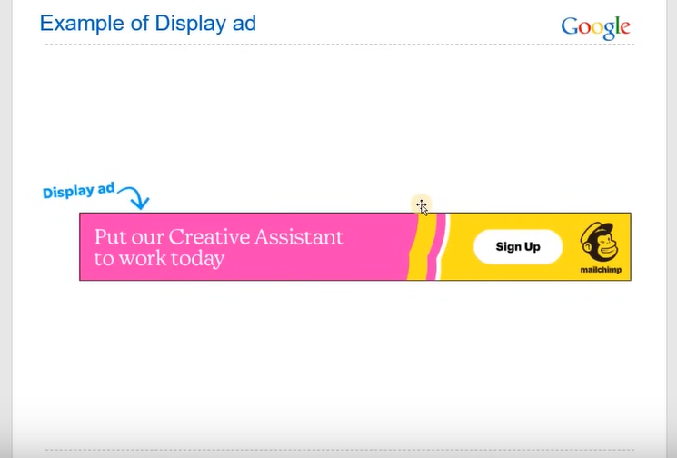

We are sure you must have seen this when you go to different websites and there you will see sponsored adds or banners and videos then they come in display category

**Phase 2**

You will find these in apps also

Teachwer search example of display ads

And then he go to images

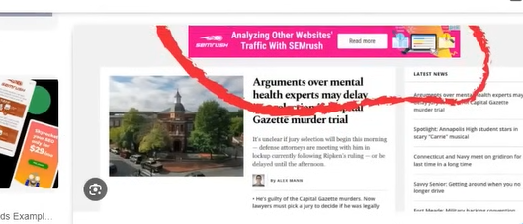

**Note:-**

The banner ads come inside display ads

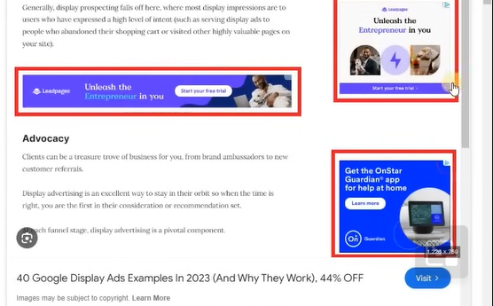

You can see above multiple banner based ads

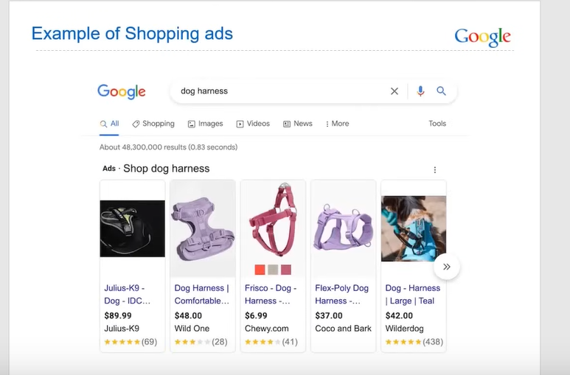

Now moving onto the example of Shopping ads

Normally they come when you search a prioduct or searching about it then you see listing related to the product as shown above we call it as shopping ads

It is not located in all locations

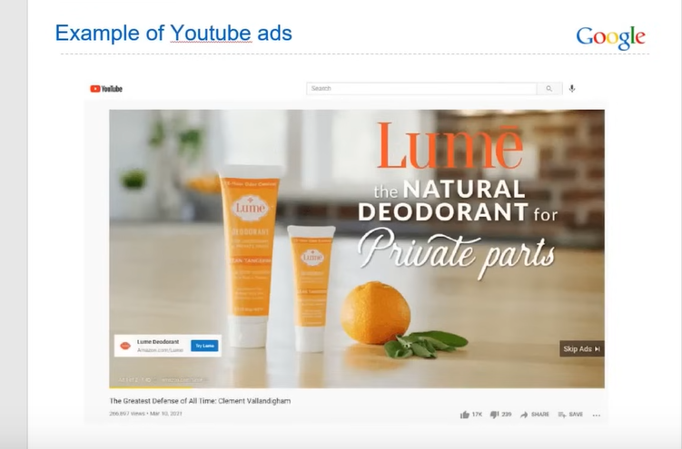

Now moving onto next one is an example of Youtube ads

You must be aware of Youtube ads wht are they how they work

You must see them in between the videos that is youtube ad

When you search something in youtube you see ads which is sponsored in video form in the top od youtube result

Whatever you see in suggesting videos is youtube ads.

12:00

Now we will see **undersanding google ads further**

We have seen some example and we will breakdown it one by one

First we will go go to Google search and then further understand how it works

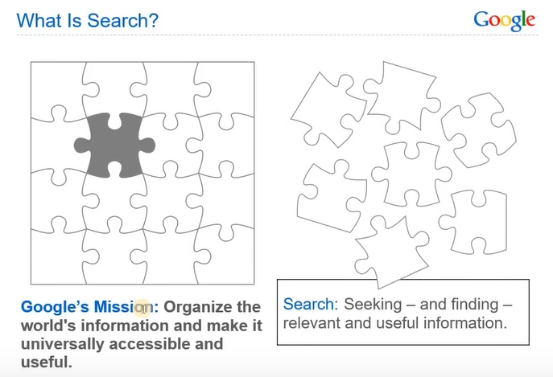

Google’s aim as you can see above and that is to make the world’s information organize and make it universally accessible and usefull

So now you can understand that’s what google do

In your one search the whole world information is in front of you

It measn google is fullfing its goal and constantly improving it Due to this google search formed

And its concept is formed

SO what is search it is Seeking and finding relevant and usefull information

Suppose you have aquestion in your mind likenHow to loose weight you search oin google, youtube that is search

Now we will see the crux about google search . Google search make finding Information simple

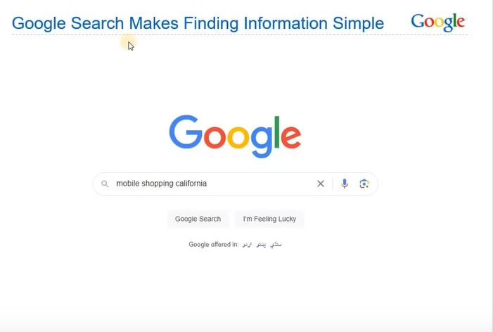

Suppose we do the searches Mobile Shopping California

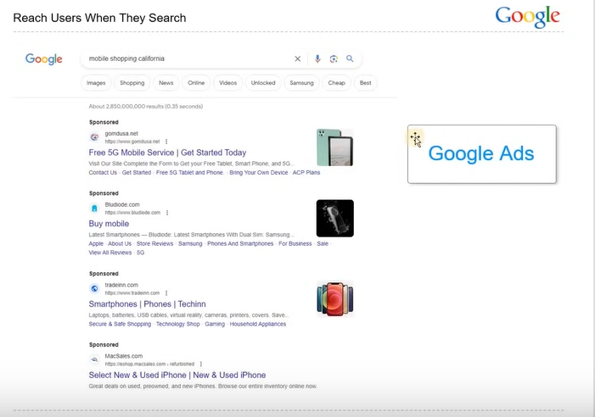

Now you can see above result which are sponsored these aer google ads

Sponsored you see is actually google ads

Now we will see google search

To understand it we need to break down what is the structure of goggle result page basically anatomy of Google Search result

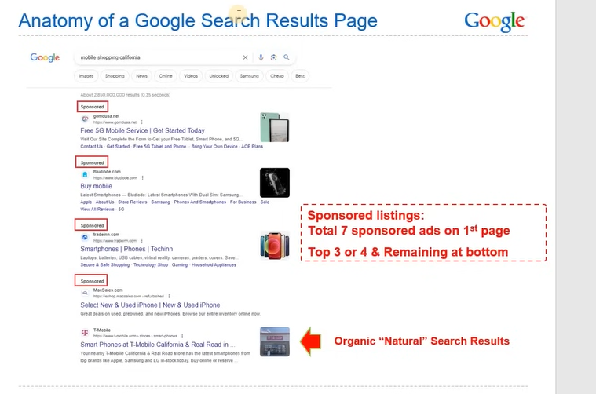

This anatomy is mostly called in technical term called SERP(in short term)

First we need to understand the structure of Google search page

First we ned to understand what is the listing we come from Google Ads and others from organic

We need to understand that there are total 7 ads on our first page

And its structure is such tht 3 or 4 come in above and rest at the bottom

Measn maxixmium limit at top is four

Now it is not important on that keyword that if the advertiser is running less ads on that keyword then you may see just 2 or 3 ads so it can vary

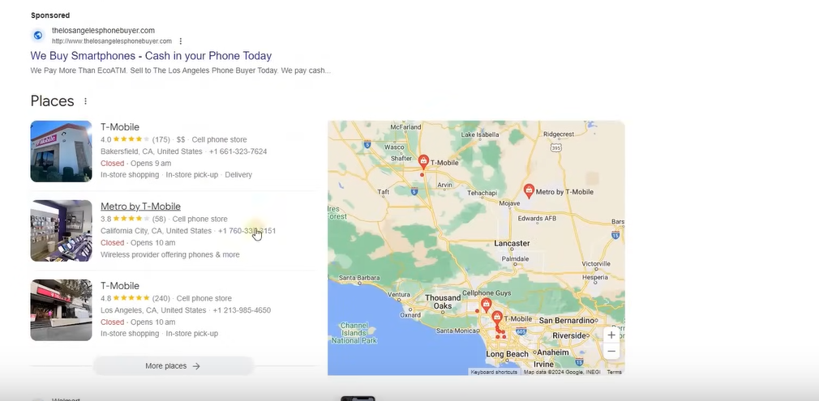

Below sponsored you can see Google listing and then you can see natural SCO generated ads

Now we will study about **Google Network**

We have understood the introdution that what is Google What are the ads type

What are there examples and then we understand search result basically there anatomy

And now we are moving towards Googel Network topic where we will start dividing the things where we will categories it and then specifically understand it at microlevel

First we will go to Google Network and then understand it what is Google Network

Google Network is further divided into two more parts

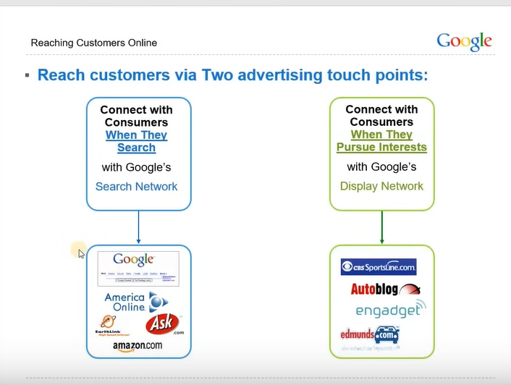

First search network and Display network

Search network work on Google Search and we also have search partners like Amazon.com, Ask.com etc So it work on them

And Display network work on different websites where access different apps

Youtube comes under it and Gmail also come inside it and Discover ads

Visually basically means Visual Ads and search basically mean Text Ads

If we try ti understand search then it means Connect with Consumers it is saying that when they search something then we can connect with them in Google Search ads

But in Google display Network case we connect when they persue there interest means in website or app normally scrolling or doing there work or watching videos in youtube then you can show ads there and gain there attention that is the fdifference between two network

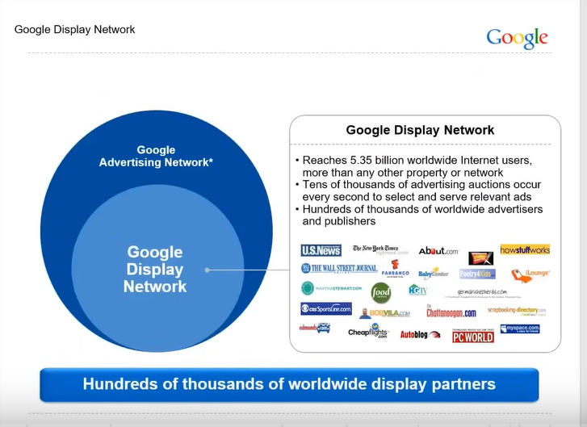

Now we will see how big is the area of Google Display Network and what are things in them

You can see in Google Advertising network Google Display Network is bigger and remaining part comes under Google Search Network

In Google Didplay network you can reach out 5.35 billioin people by any property or apps or website

Here you can see many websiter or advertisrer may be present there

Publisher are those who have websites or apps and the advertisers are those who will run ads on them

So worldwide thousand of partners are available

SO this is a very big thing

It is very bugger as compared to google search network

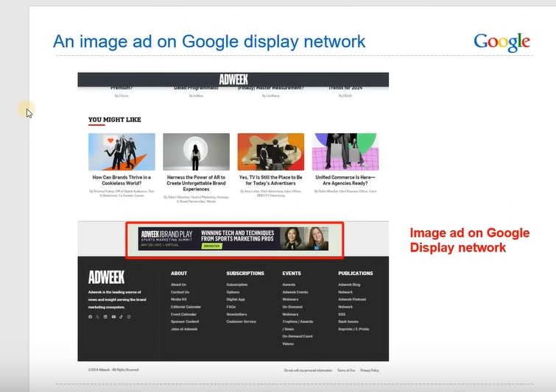

Above is an example of image ad how it get shown in our network

Now we will study next topic that is Google Value Proposition

This thing is very important because Google is competing to different advertising tools like facebook , Microsoft , Instagram or where the advertiser get attracted and use advertising tool

And they are its competitor

**Phase 3**

So How google is unique is from them we need to understand it

The first important point in Value proposition means what value the google provide as compared against other advertising tools

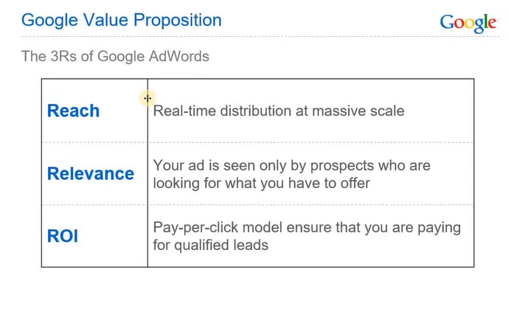

First is Reach that is Real Time distribution at massive scale means nobody can challenge the reach og google ads

No platform has user base as compared to google (Youtube , Discoever etc )

Second point is relevance

You have targeting options

Suppose some one you are selling iphone and someone search buy Iphone and I will ad run for him then there’s more chance of selling so relevance is also highest there that the time they are searching something you show there ads

Now the third point is ROI

It measn Pay per model benefits you that you are paying for qualified lead means you are not paying for impression , views you are paying for click that gives you more ROI to your business

**Lesson 2:-**

In this lesson we will learn about **How does Ad Ranking Works**

Now we need to understand that how your ads get ranked and on the basis of what

Now you definitely understand there structure

Now when we understand the structure of anatomy yhen this question comes in our mind that How we will decide the ranking and how does the Google decide in what position to rank us

So we will understand it in this topic

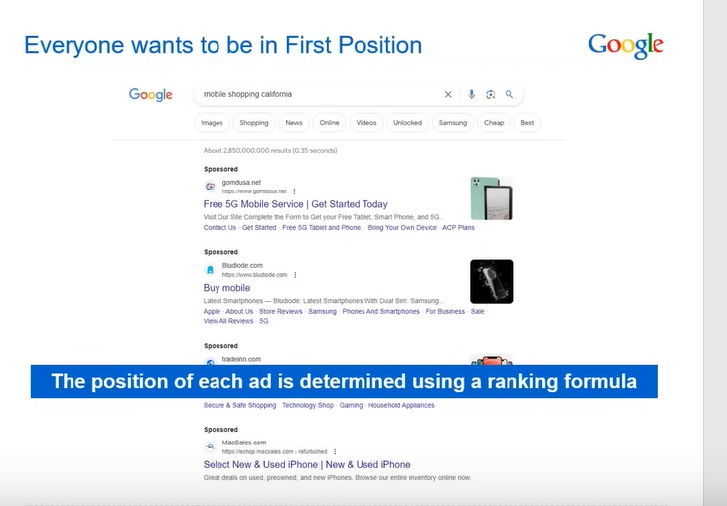

The position of each ad is determined using a ranking formula

For that Googel has introduced auction system

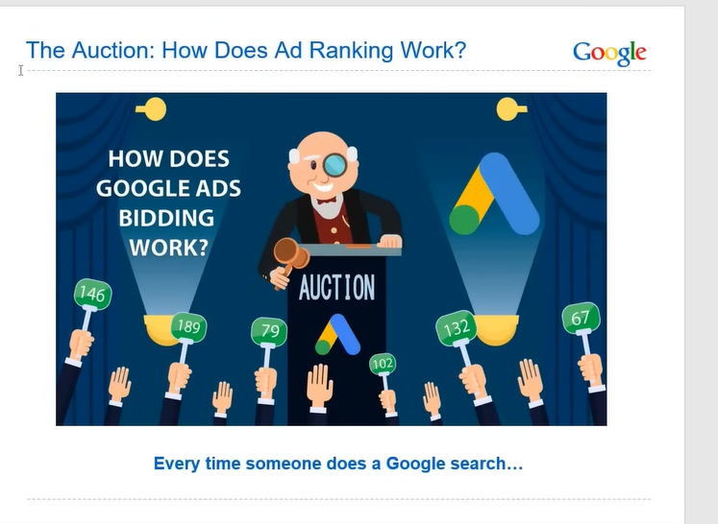

The person who pay higher prices will get upper rank but ther is a twist everytime someone search a google search then bidding goes on and the person who bid more his ad come in upper rank Now there is a twist that teacher will tell us in a while

The formuala Google ahs introduced is as shown below

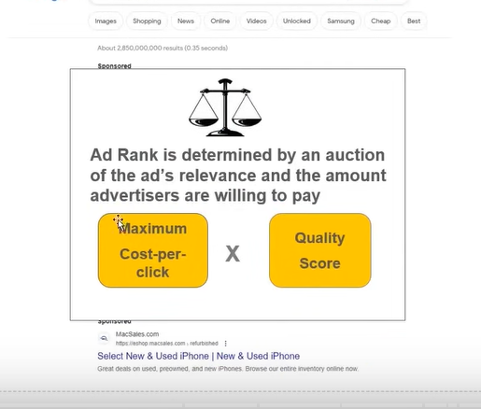

Ad rank = Maximum Cost per click X Quality Score

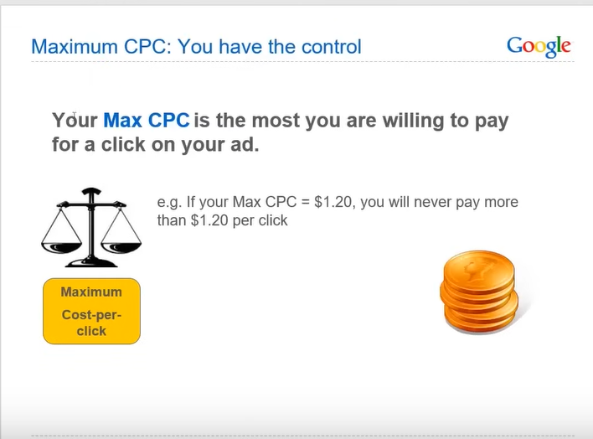

By MaxCPC we mean how much maximum you want ot pay for a click

Suppose we want that there should be aclick on our ad then we want that only 1.20$ is charged then Google will not charged you more than that

Now we comes to quality score

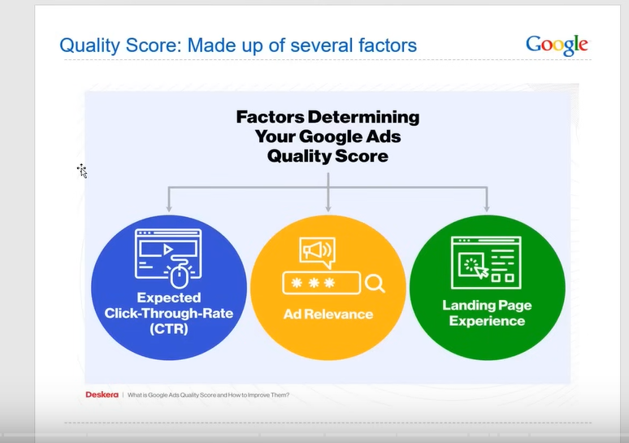

If we define it further

Then this quality get break down into three factors

First is expected click through rate

Second is ad relevance

Third is Landing Page Experience

Expected Click through rate means for example yiour ad is viewed by 100 people and among them 20 people click on it then you r ctr would be 20 percent because out of 100 20 people clicked on your ad

Formula of CTR would be ratio of number of people click on your ad ot the peple who view your ad

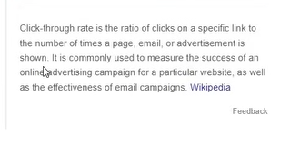

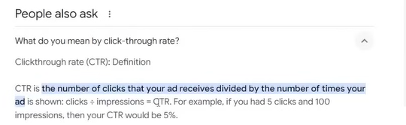

Now we will understand ad relevance

To understand we take an example we search mobile shopping texas

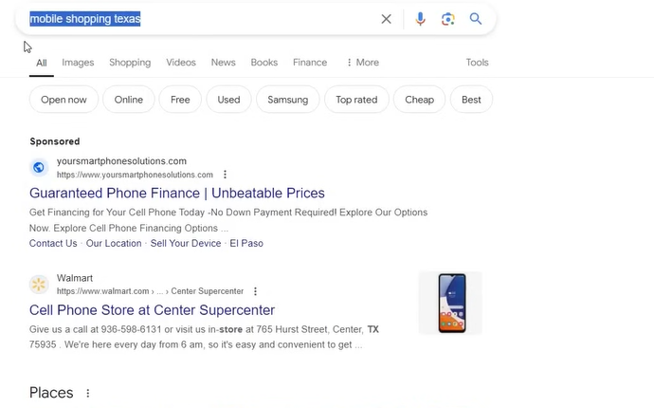

Whatever we are searching are we getting it or not or are we getting irrelevant things this is called Ad relevance

So when we search Mobile Shopping Texas then we can the ad which is sponsored is not relevant so that ad loses point is reduces its ad relevancy point but the ling belwo it has relevancy

Whenever you are searching something and the ad is not relevant to the keyword then that means your are not fulfilling the requirement of Quality Score

The requirement of quality score is that your ad should be relevant

You should produce relevant ad

If you are showing wrong ad to to wrong audience not relevant tot them then your budget would be wasted and your quality score gradually will be wasted

Thirrd point is Landing Page experience

It measn customer come in your website and want to purchase something then he should not face some problem in purchasing something

In Some websites The link does not open or the funstionality of landing page is not properly working , if we are doing checkout hten checkout error comes Pages are not built properly designs are not good

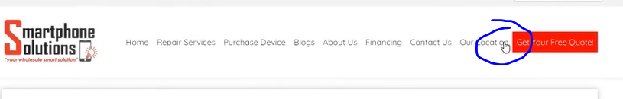  
you can see above that there is no proper gaping between menus and there are lots od menus. Content is very less

Or whatever link is used for ad does not have content

The landing page user experience means how it is easy for a user to purchase in your website or contacting you

Qulaity score is on the reange of 1 to 10

Google assign anything on the basis of that your qulity score will be decided

When we start then the quality score is by default 6 and on the basis of your performance it reduces or increase For some people it can be reduced to 3, 4 or 2 and it can even go to 8 or 9 depending on there performance

What quality score work was done it depend on it

And if we further try to understand this Why google introduces Qulity Score

If Google wanted then it could

**Phase 4**

Have kept cost per click

Google could have wanted that whoever paying more should be kept above then it will be profitable for it

But by this google can see users benefit and its own benefit

By this all three of the people have benefit who are Users, Advertisement , Google etc

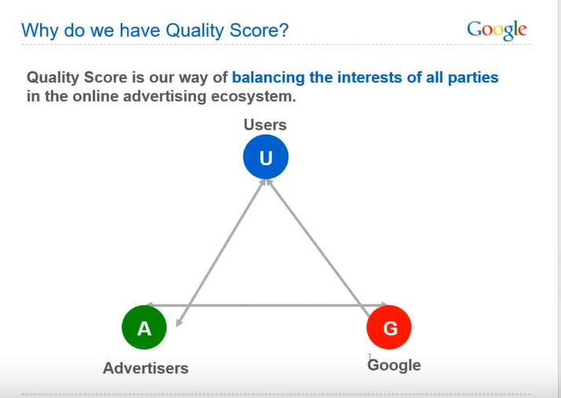

Now we will see the benefit of Advertiser

If the advertiser work on quality score then in less many he has higher ranking

He is paying less many and his quality score is good and he is ranking up and if the advertiser who is paying great money but its quality score is low then he s being ranked low

Mean The benefit advertiser get is paying less money and get chance of ranking up

User benefit is that if the advertiser is focusing on the quality score then he will try to create automatically quality content like we see ad relevancy , landing page experience

By seeing this he will create good ad and produce good landing page by which user has benefits that he is getting the thing he want

And Google benefit is that User will not go anywhere he will come back to Google because he gets useful information there that he can use Instead of using other search engine he will become a repeated customer of Google . The benefit of Google is that its active user will increase nad user benefit is that he will get good experience the advertiser benefit is that in less money he will get good ranking by this a balanced ecosystem is formed like a Triangle

It balances all three of them Means all three of them gain the benefit

The quality score is introduced so that an ecosystem is formed of three of them gain from it

Now we will see an example to understand How ad auction will work

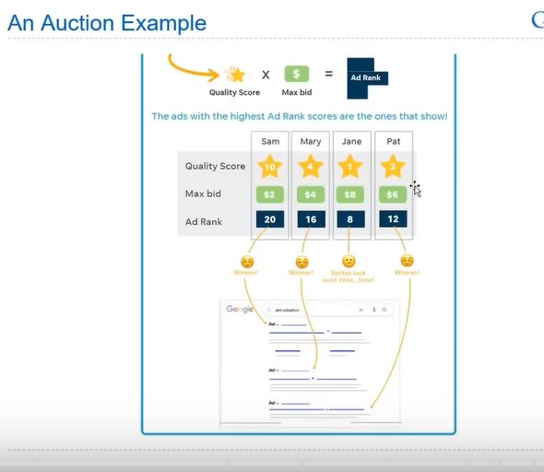

Now from above example we have four people Sam, Mary, Pat, Jane

Now we will see the influence or effect of quality score on your ad rank

First we will se of lowest budget person from above image that is Sam

His quality scire is 10 and Max bid is ad 2 so the ad rank is 20

Mary’s quality scoire is 4 and the max bid is 4 so rank is 16

Jane’s quality score is 1 and the max bid is 8 so rank is 8

Pat’s quality score is 2 and the max bid is 6 so rank is 12

Now we compare them

The person who has higher ad rank number will have highest ranking

And with decrease in number ad will be decreased rank will be decreased

Now we can see that Sam has paid the least that is 2 dollars and others have paid 4, 8 and 6 dollars but still Sam is the winner he is coming in first rank then comes Mary Pat and Jane

Jane camed at end instead he is paying more

Now you can understand that why quality score is important and how it can affect your cost so much

**Lesson 3**

In this lesson we will learn about **Campaign Setting Part-I**

The first thing come inside Campaign Setting is Account Structure

If we see the account structure of Google ads then we try to understand that

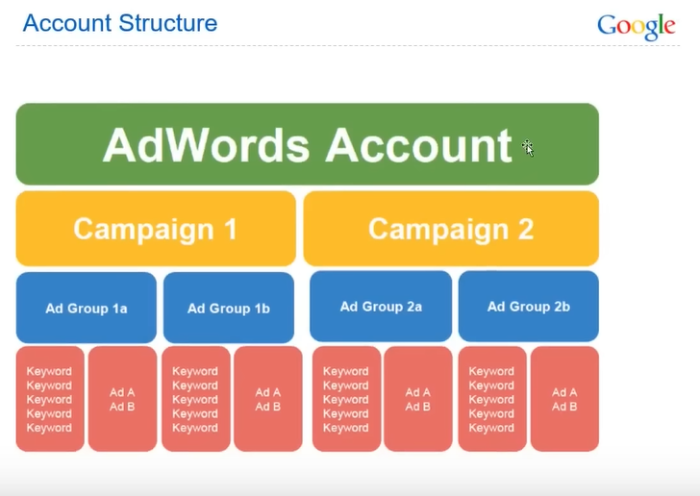

In top hierarchy we have Adwords account or ad account

Adwords is written because previously Google ads were called Adwords

So is you see adwords in place of Google ads then don’t get confused

And now below it campaigns or multiple campaigns and in every campaign there is ad group

And every ad grpoup contains keyword and Adcopies

Adcopies cann be upto 3 per ad group

This is the account structure by following which we can understand these things in detail How Campaigns are formed , Ad groups are formed

What are the best practices of keyword , what are the best practices of ad copies we will understand everything in detail

For now you have to uderstadn what is the structure of the Google Ads account

And now if we try ti understand this thing in detail

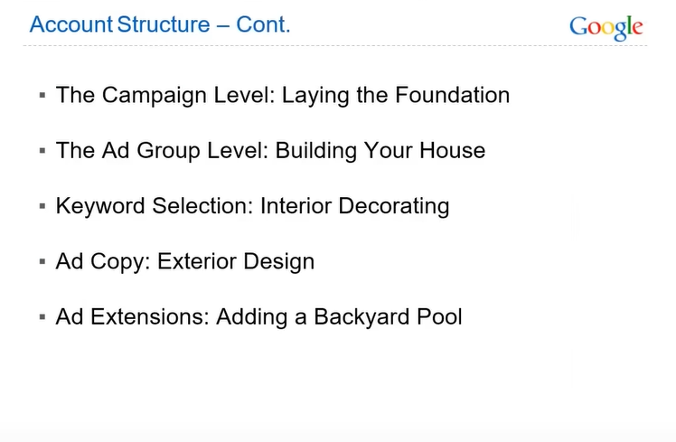

In above we have given context

SO campaign level means laying the foundation means we are making a home we are laying a foundation

Then ad group level mean we are building Houses

Now Keyword Selection means Interior Decorating

By ad copy we mean we are designing Exterior

By ad extension we mean Adding a Backyard Pool

This is the additional thing in your house If it is not there then it affects that much but good look comes because of it and your house beauty gets advanced

We select keyword we see it we know what keywords was selected that’s why it is called interior decorating

We call ad copy exterior design because customer sees it whoever searched it sees the ad

So it come inter exterior design

You add a backyard pool after exterior design only customer will sees it

It will not be limited to you.

Now we will understand the type of Campaign

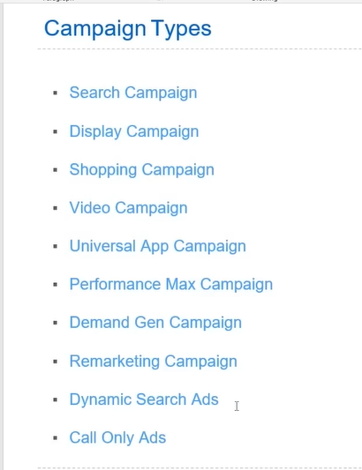

Some comapign from bottom 3 are not specifically any category

These forms in hidden way(I don’t know who knows)

We will see each and everything in detail

Now just you have to understand that these type pf campaign that we need to understand

Now we will do practical

SO first we will learn how to create Ad account

SO first search

ads.google.com

NOw you will see the interface below

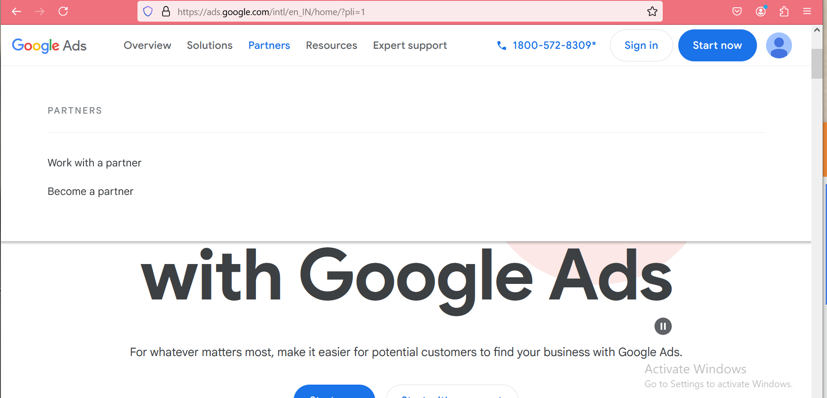

Now we will sign in with our google id

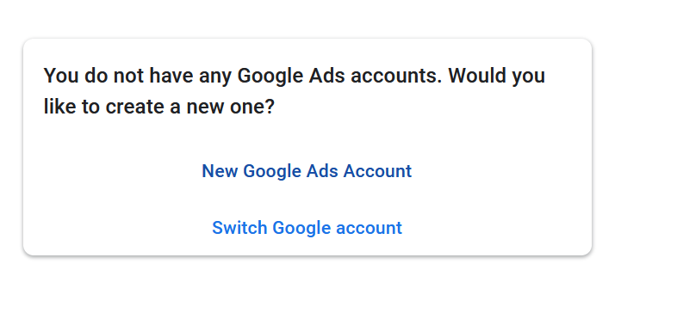and now in new page it will show above two option that is

If you want to create a new ad account or Switch Google account

**Phase 5**

If you had already an ad account in this then it would have been listed there

Since we don’t have any we will click on New Google ads account

Now this is a very important and crucial step about how to create an ad account

Many people mainly do mistake here that they don’t create ad account properly then there campaign did not perform properly and they face problem in convergence tracking

SO make sure we do all the thing from step 1 whih is creating ad account

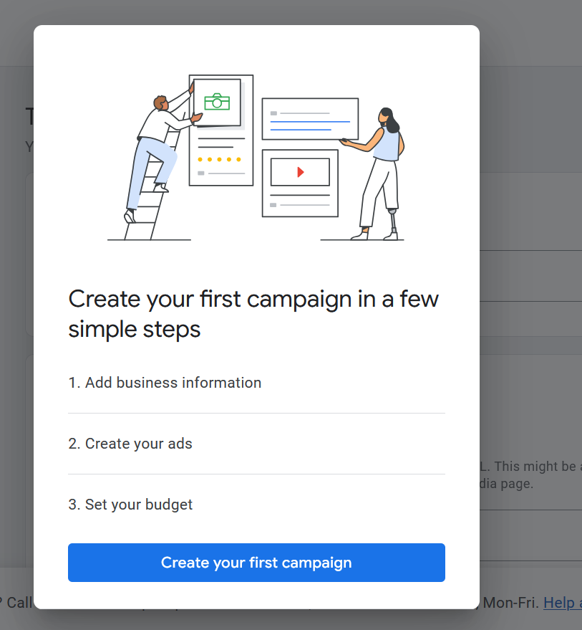

Now in your page above will be shown now click on any empty are ato remove this prompt

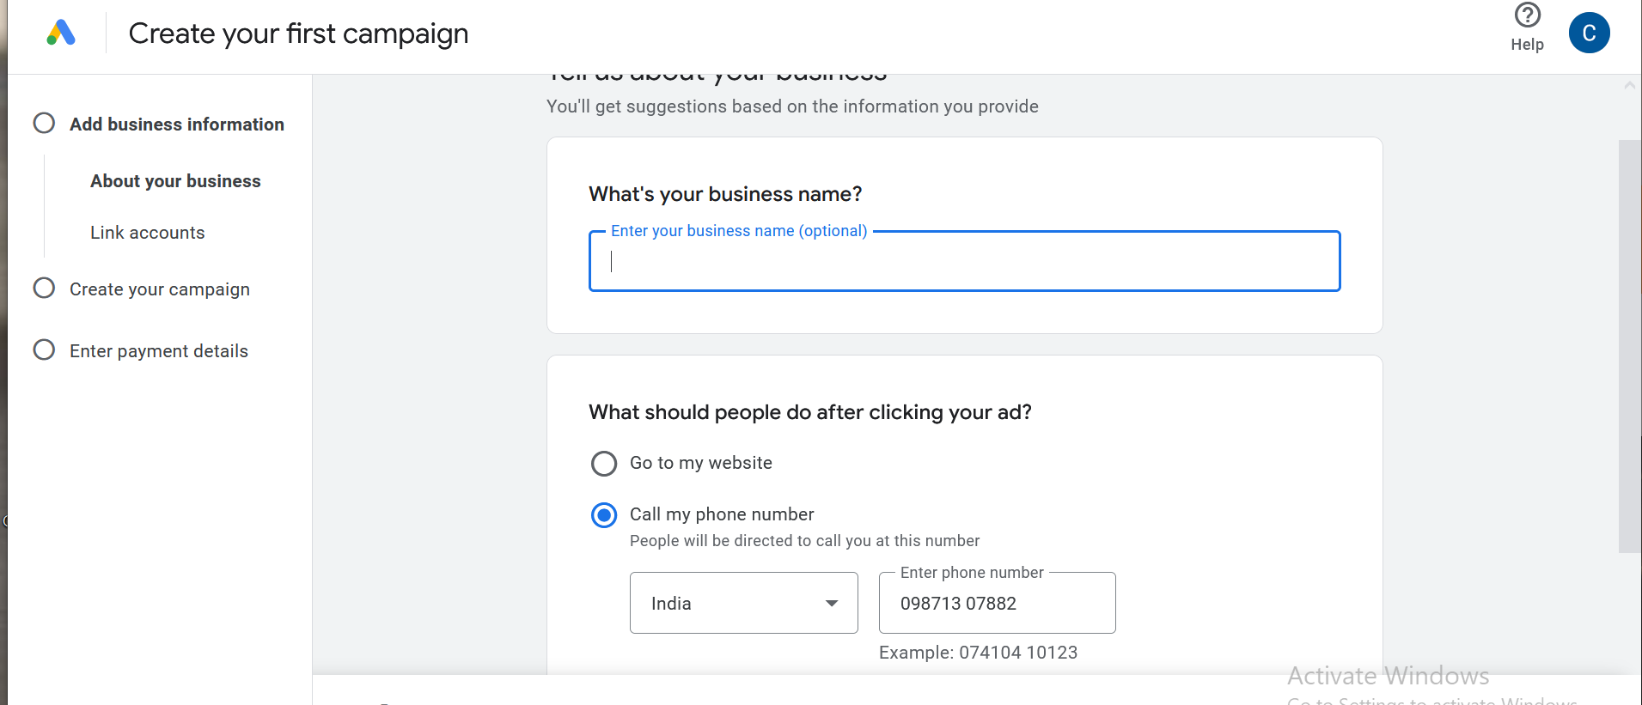

Now above screen will br shown we need oto skip this campaign creation so that

We choose the call my phone and enter my phone number and then click on next button blue ion color

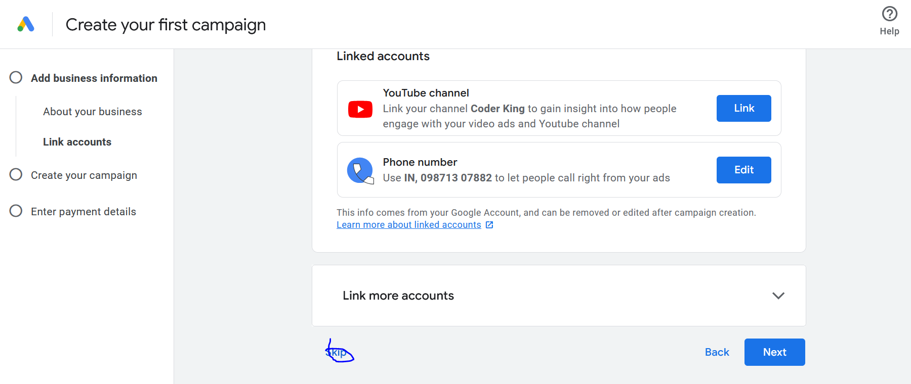

Now click on skip in new page as marked above

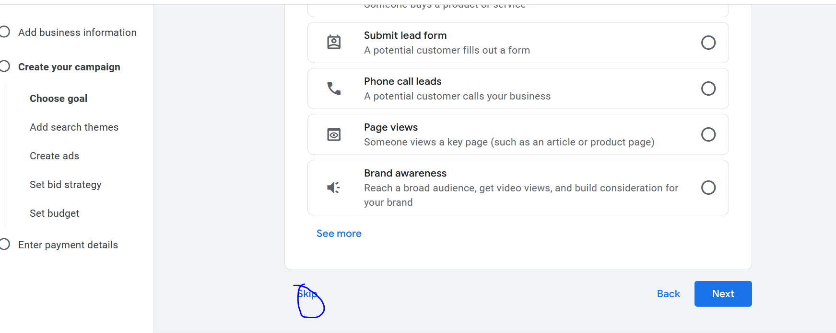

Now again click on skip button

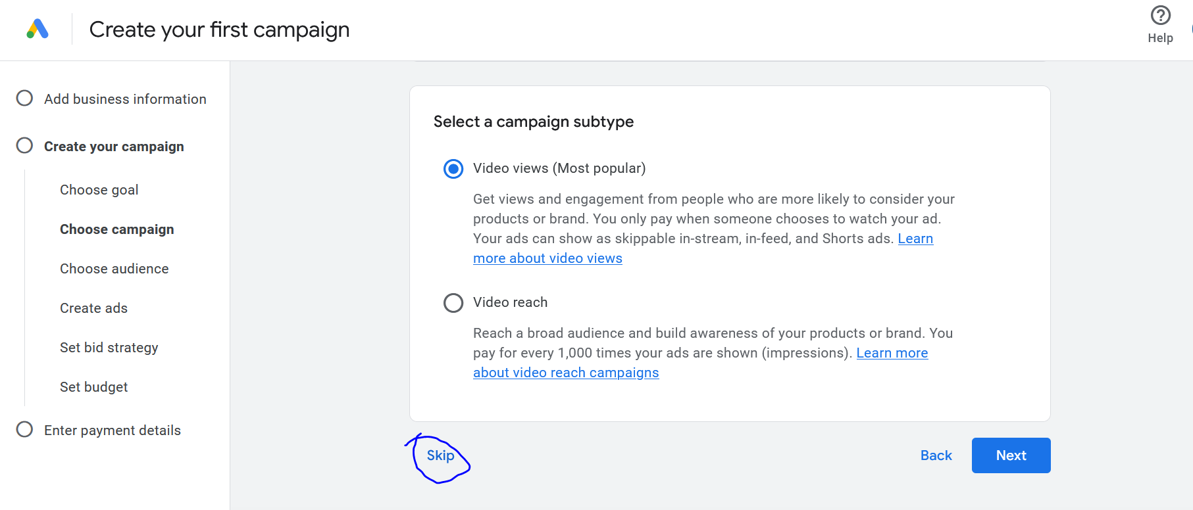

Now again click on skip button

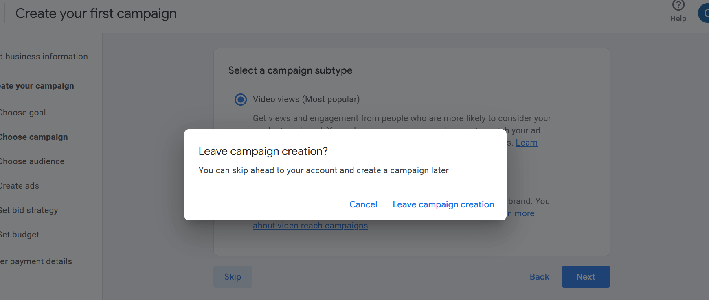

Now this time a prompt will be shown click on Leave campaign creation link

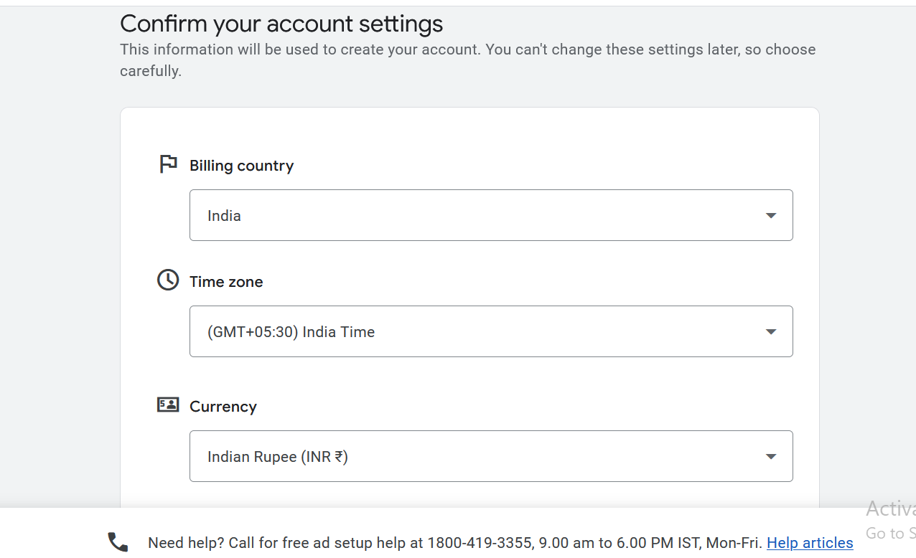

Now we will be shown above

Now it is asking billing country , Time Zone , Currency

Make sure you set them correctly later you cannot get the option to change it

SO make sure you set things correctly according to the country where you are running the ad and the countyr’s card you are using (who knows)

Now click on continue button

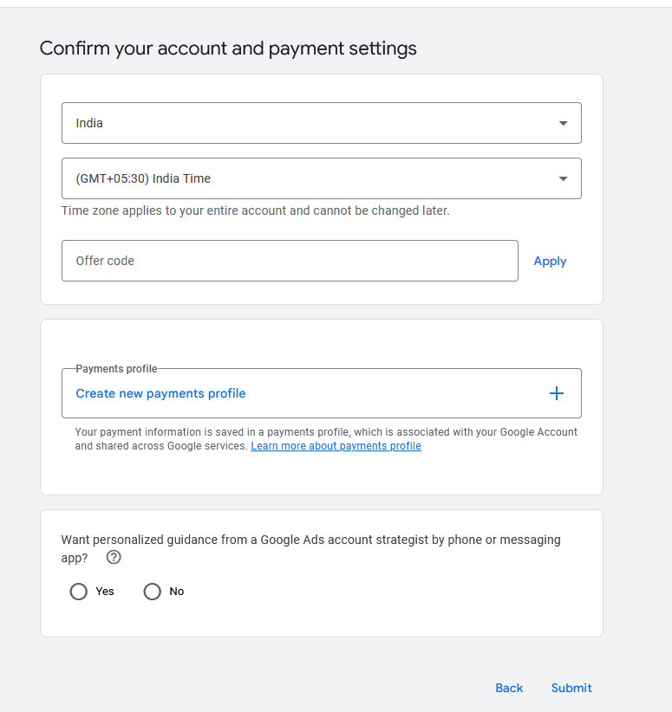

Now you will be shown above

Click on no in the last radio button

Now if you click on Create new payment profile then it will prompt you to fill a form to add a payment profile

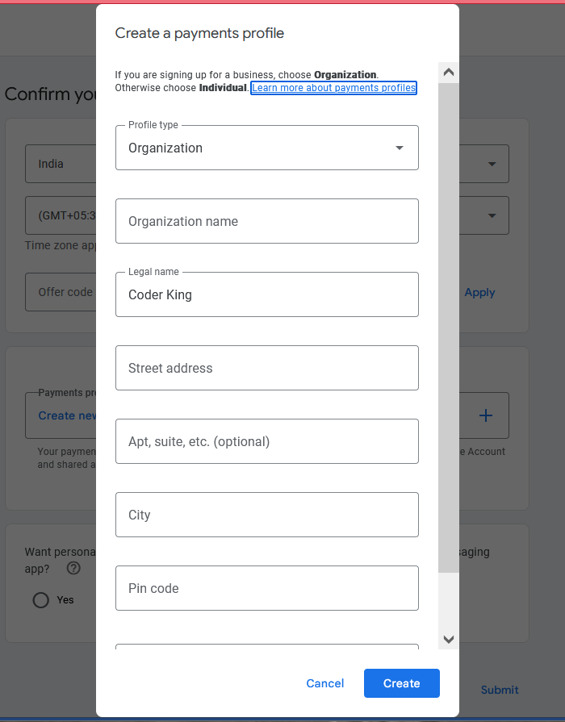

Because in new update you have to pur payment profile and payment method

After filling the form click on create button

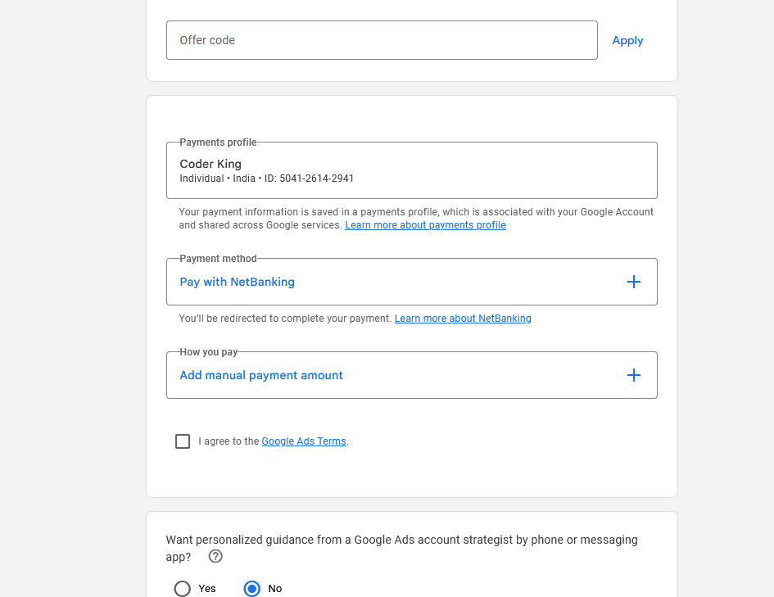

Now it will ask you payment option I choose

If you chose debit card then make sure it has less money so that you are not charged here

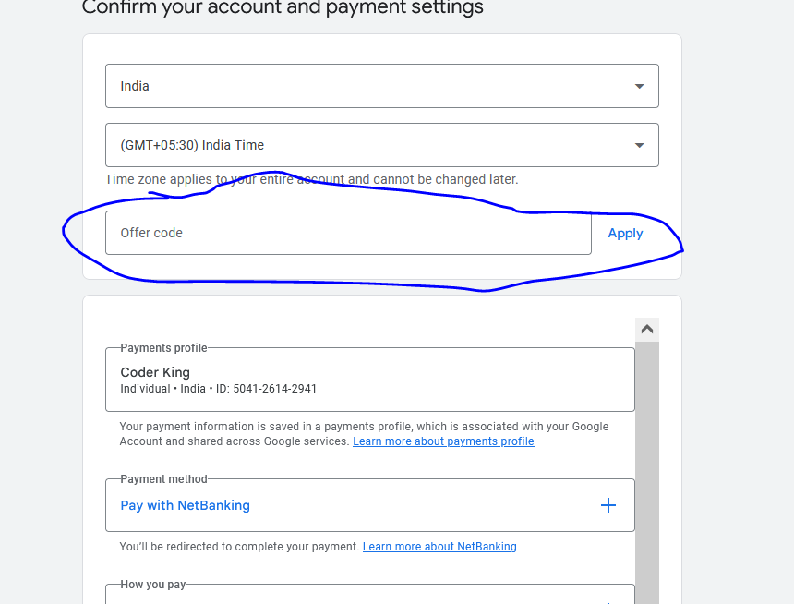

You can also click on the marked above so that you can get the offer here

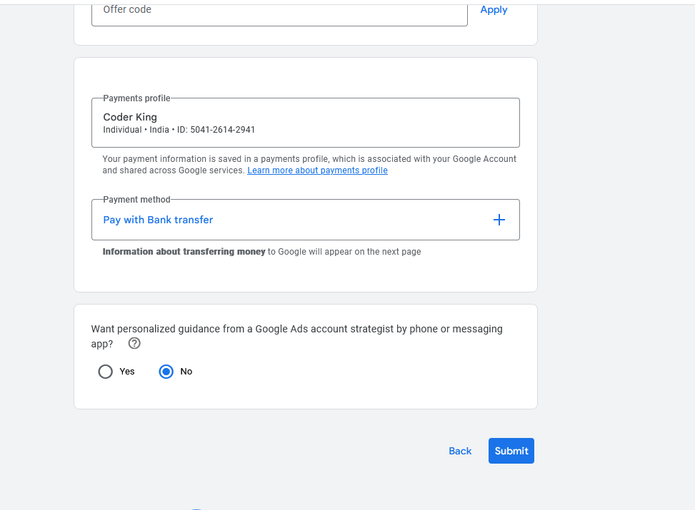

I chose payment with Bank Transfer

Now click on Submit button

NOw you will be prompt to save the bank transfer information

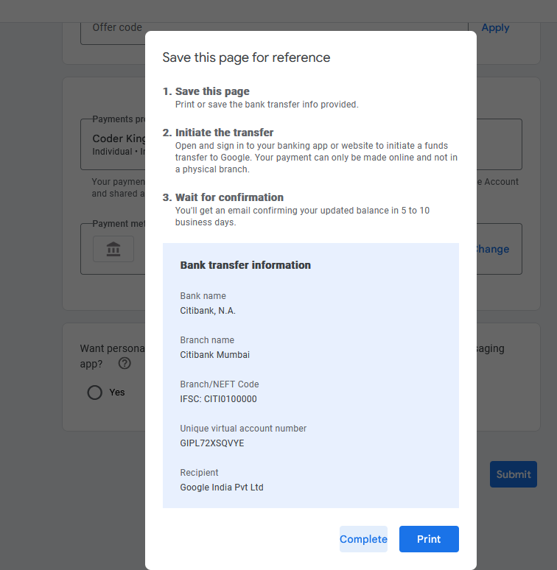

Now click on complete

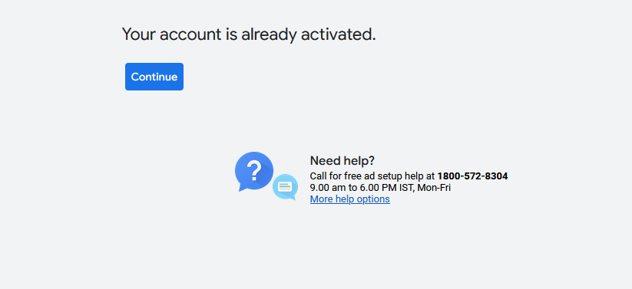

And now above page will be shown now click on Continue button

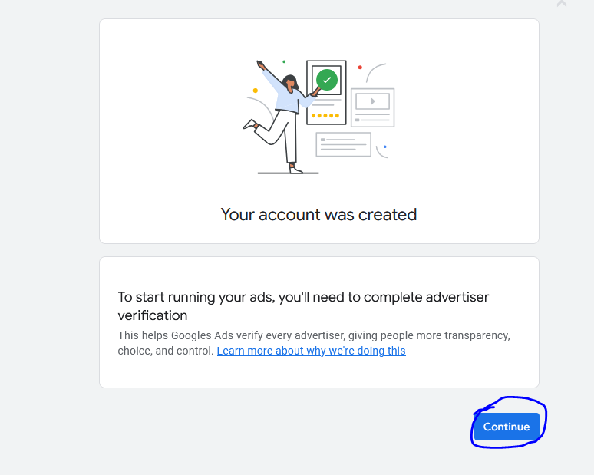

Now again click o continue button

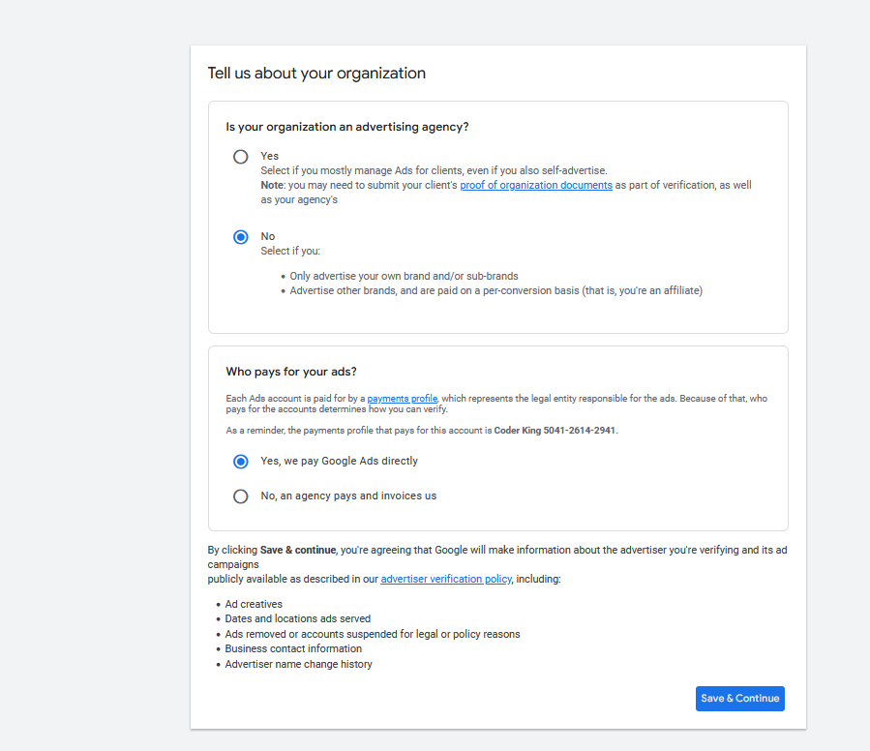

We did the above configuration

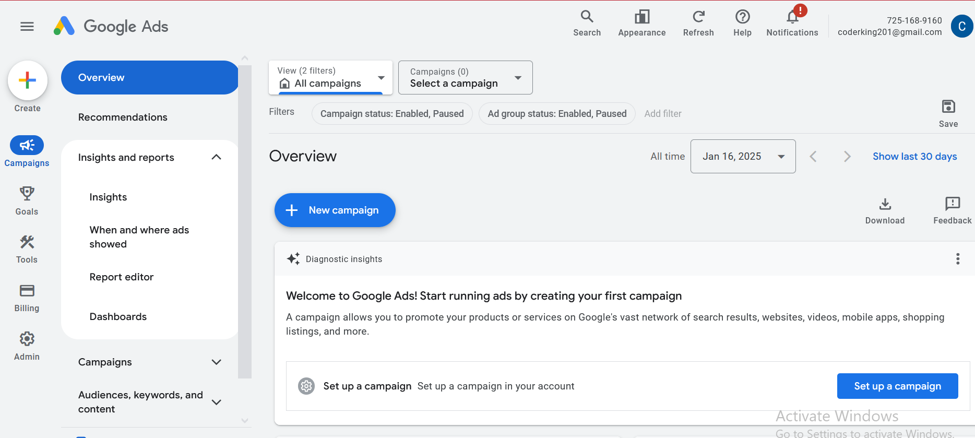

Now above interface will be shown that is our ads account

You need to be comfortable with the interface

Whatever interface is you have to be comfortable with it

I think the overview side menu is a dashboard

We will understand campaign settings

Now we will create a campaign

SO go to Campaign sidemenu and then extend it and then go to Campaign inside it

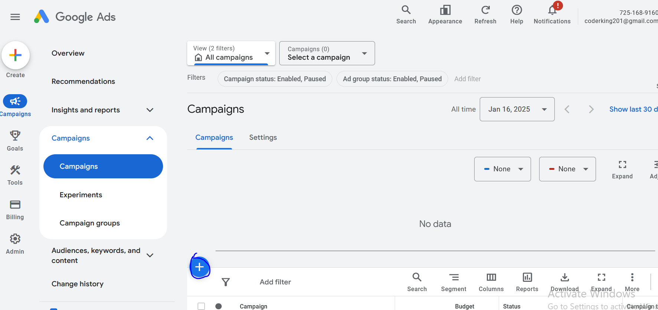

No click on + button as marked above

Now a menu will be opened

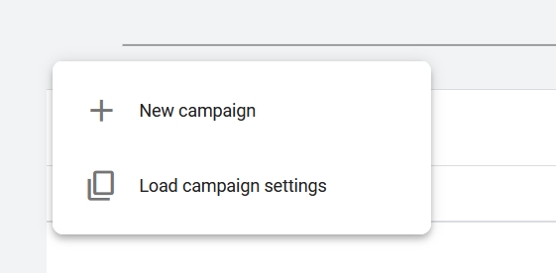

Click on New Campaign button

First we will understand how to do setting of the campaign because in our structure after ad account creation Campaign comes

Now Below screen will be shown

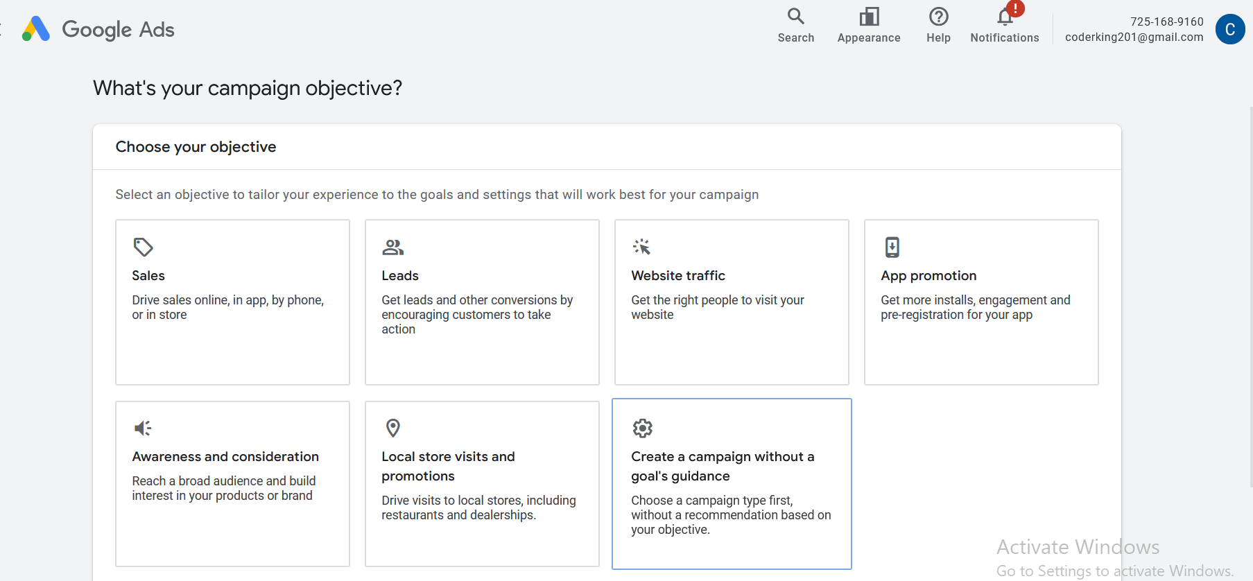

Sales is for Ecommerce website and Lead is for Lead generation